NAME : | BHAVYA JAPPI | DATE : | 07-08-2026
AGE/SEX : | 22 YRS / MALE
REF BY Dr : | RONAK SHAH
X-RAY: LEFT FOREARM (AP/LATERAL VIEW)

The radius and the ulna appear normal in mineralization pattern.

There is no evidence of any obvious fracture seen.

The surrounding soft tissue appears normal.

The proximal and distal radio-ulnar joints show no abnormality.

REMARKS: No obvious abnormality is seen.

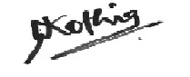
DR. NIKUNJ KOTHIA
CONS. RADIOLOGIST

